**Title : Design Pattern based digital lock system**

**Input:** The users will be provided with a keypad for giving input to the system.

**Output :** There will be two types of 7 segments.

7 segment 1: Any input given through keypad will be displayed here.

7 segment 2: If the pattern is correct the result will be displayed in this 7 segment display. Result can be just a letter printed on the 7 segment (O/N).

**Modes:** A user will have two modes to operate the lock. In mode 1, the user can store a specific pattern. In mode 2, user can input a pattern that will be matched with stored pattern. Mode 1 is an advanced requirement and should be attempted only when mode 1 is complete. Mode 2 is the minimum requirement of the project.

**Sample pattern:** The pattern will be fixed for those completing only mode 1. It will consist of the 5 digits in following sequence - sec. no followed by group no and last 3 digits of ID. Say, If you are from Sec 5, Group 4 with an ID 13306996042 the fixed pattern will be 5 4 0 4 2. If different group members have different last 3 digits, you can pick one of them.

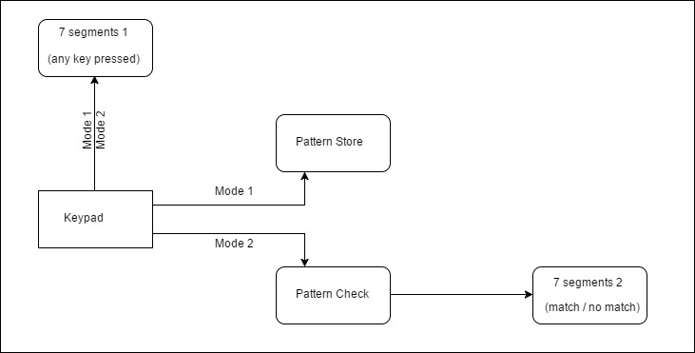

Block Diagram of the System

**Deadlines:**

1. Combinational Part – 26/03/2017

2. Sequential Part – 09/04/2017

3. Final Project – 16/04/2017

**Submission type:**

1. logisim circuit

2. Detail design (pen and paper)

a. Specification with blocks

b. Truth Table

c. Canonical form of functions

d. K-map

e. simplified function

**Group tasks:** You must list out the name of the members and who has done what part of the project.

**Marks distribution:**

a. Design (Report) – 40

b. Logisim (Demo)– 30

c. Viva – 30